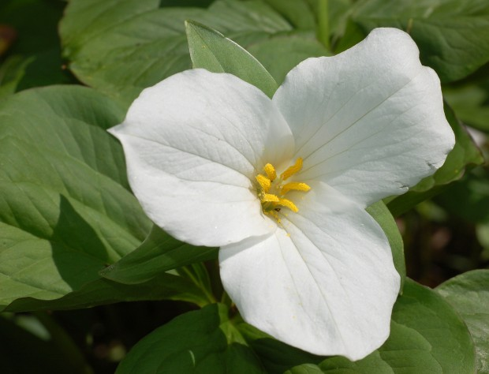
Boyne Valley Garden Club Donation Request Form
Please mail completed form to: Boyne Valley Garden Club, P.O. Box 386,
Boyne City, Michigan 49712.

Name of Organization: ________________________________ Year to be used:

Contact Person: __________________________________ E-mail Address:

Telephone Numbers: home________________________ Cell No.:

Criteria to receive funds: Check all those that apply.

Project creates further interest in horticulture, gardening, floral and landscape design, plant and
bird life, and the appreciation of the natural beauty of the State of Michigan.

Project promotes further interest in horticulture, gardening, floral and landscape design, plant and bird life, and the appreciation of the natural beauty of the State of Michigan.

Project educates in the knowledge of horticulture, gardening, floral and landscape design, plant and bird life, and the appreciation of the natural beauty of the State of Michigan.

Project encourages civic beautification.

Project assists in the conservation of our natural resources.

Write below a brief description of the project (including its location).

_________________________________________________________________________________________

_________________________________________________________________________________________

_________________________________________________________________________________________

Amount of the Request: (Financial Plan—use of the money)

Name of organization and amount of other monies received from other sources:

Name of Person Submitting Form: ___________________________________ Title:

You will be notified if your request will be honored with six weeks of submission.

